Module 5

Advance topics in a function

1) Write a function add to add two numbers and call the function in another file.

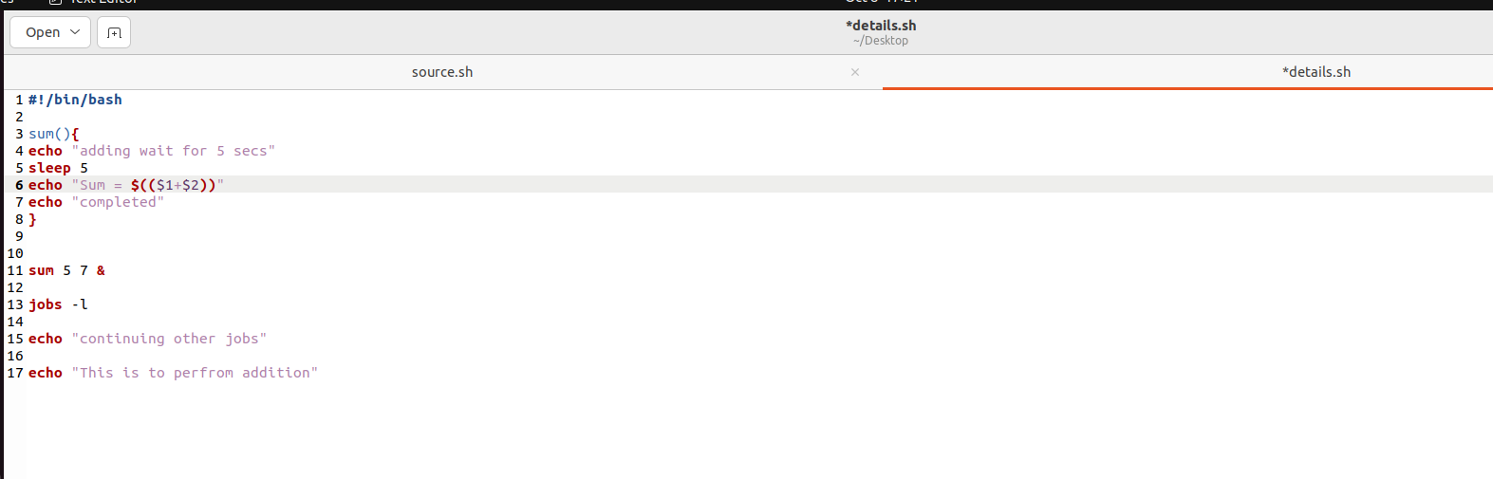
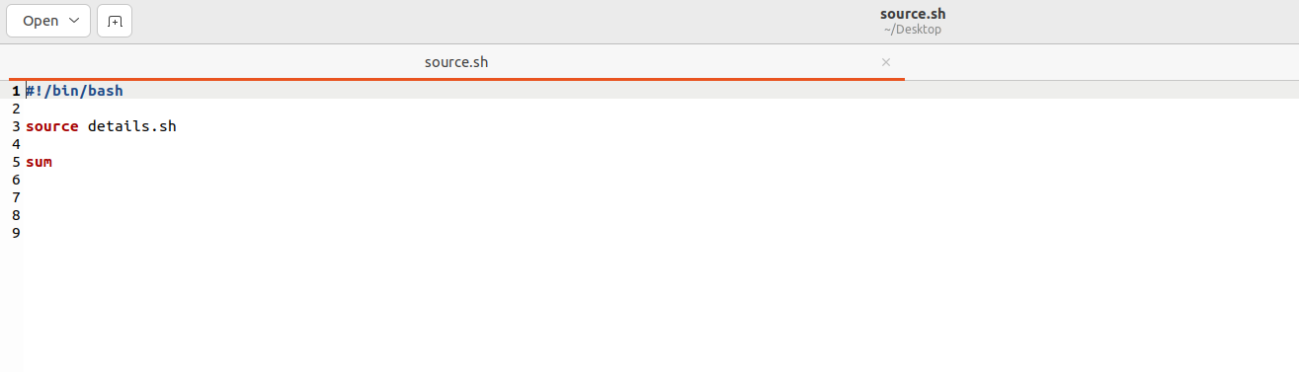
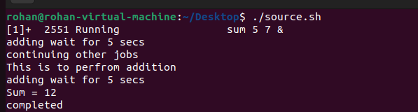

Recursive function

1) Write a program where the recursive function calculates the sum of N numbers
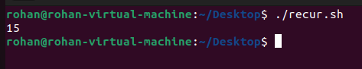
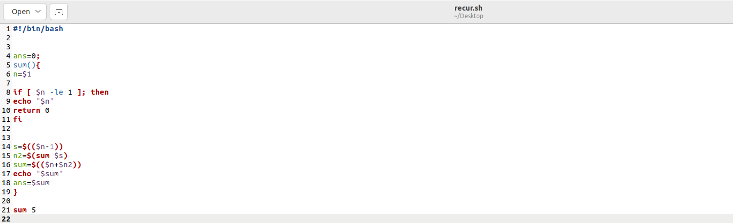

Basics of Redirection (error handling)

1) Write a program in any language like C, C++, Java.
2) And redirect the output or error to a new file.

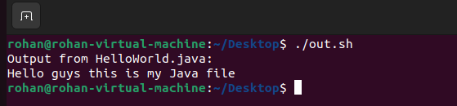

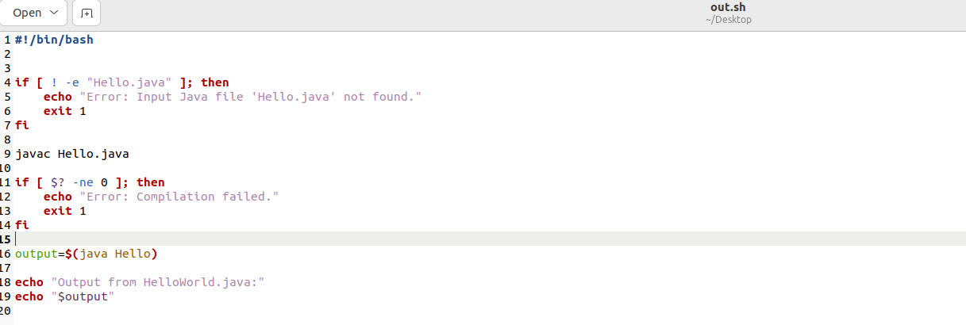

More on Redirection

1) Create X_file.txt file with some content.
2) Redirect the content of both out_file.txt and X_file.txt to a new file
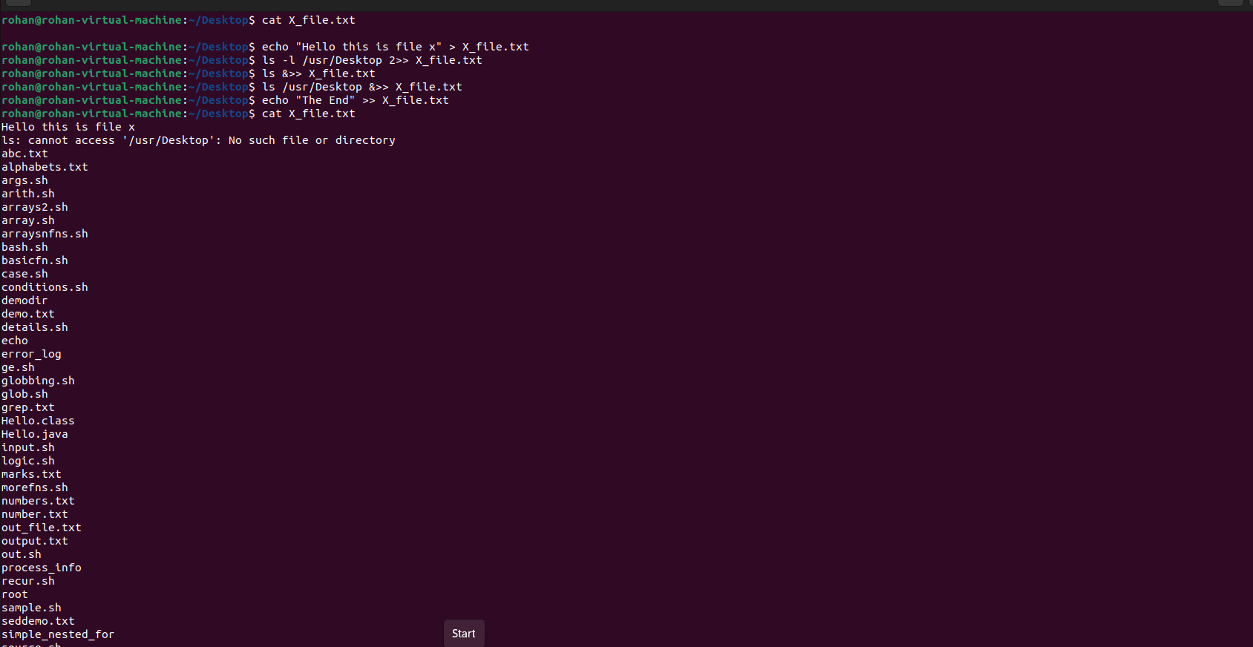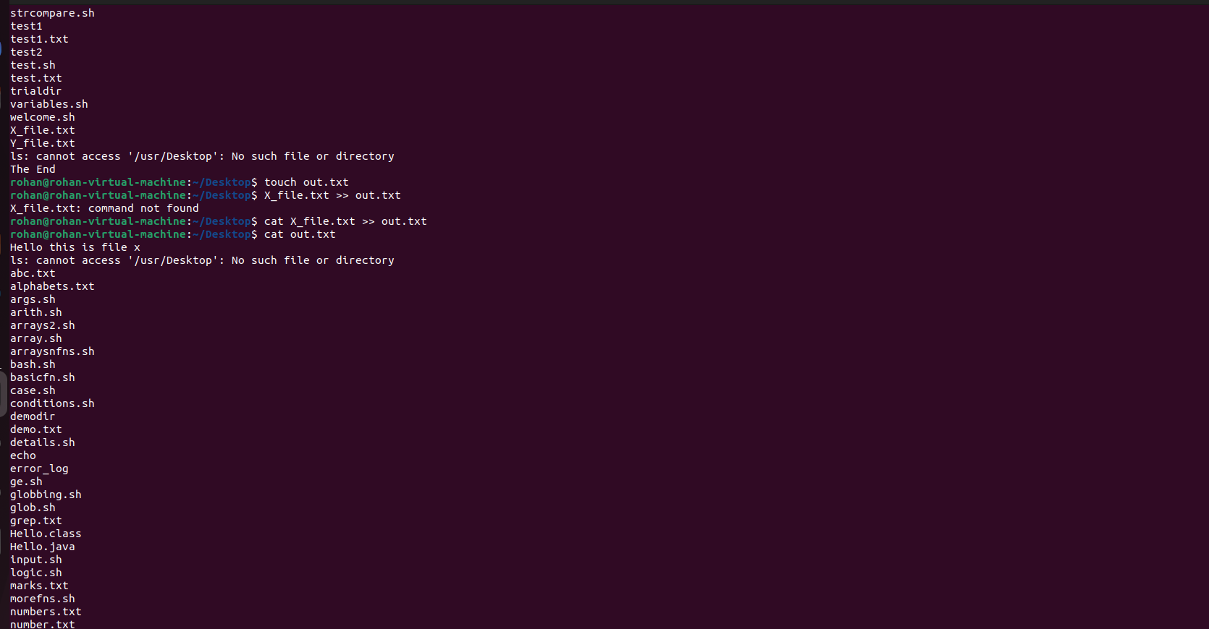
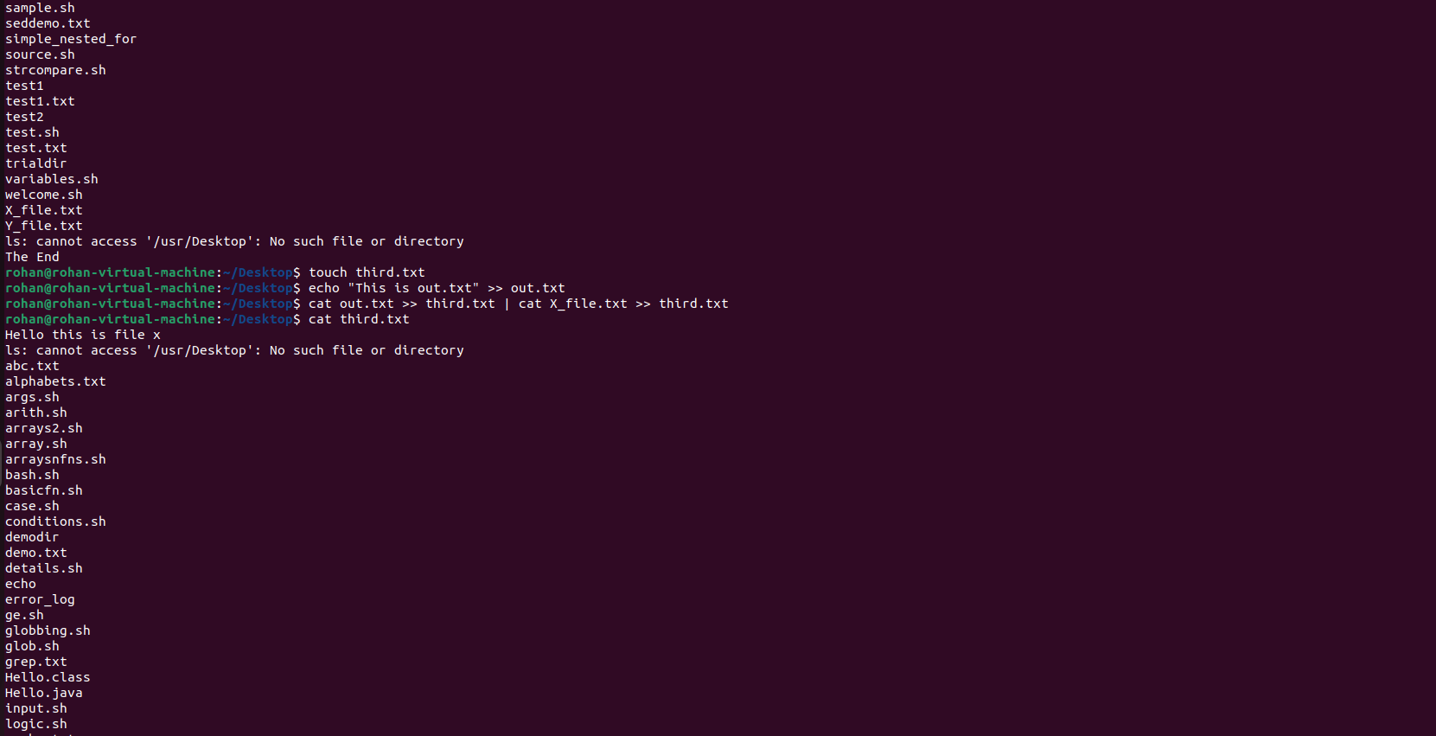
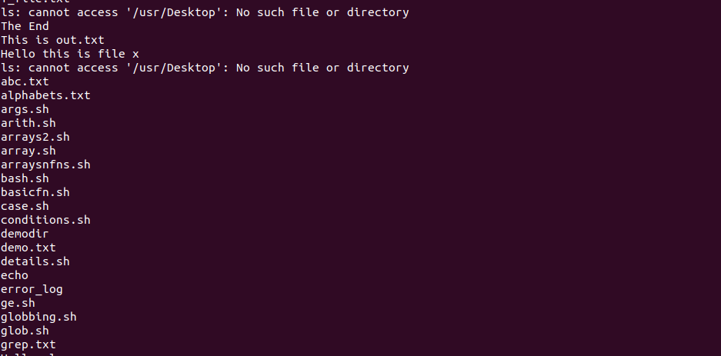

Here document and Here string

1) Convert a string to uppercase using:
a) Here document
b) Here string

Hint: tr a-z A-Z

